LAB-4

Submitted by: D Veera Harsha Vardhan Reddy;210258

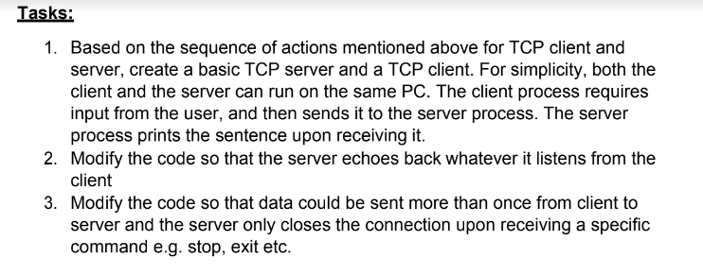

Server.py

Code:

from socket import *

serverPort = 4

serverSocket = socket(AF_INET, SOCK_STREAM)

serverSocket.bind(('', serverPort))

serverSocket.listen()

print('The server is ready to receive')

while True:

    connectionSocket, addr = serverSocket.accept()

    sentence = connectionSocket.recv(4).decode()

    capitalizedSentence = sentence.upper()

    connectionSocket.send(capitalizedSentence.encode())

    connectionSocket.close()

Client.py

from socket import *

serverName = '10.7.4.71'

serverPort = 4

while (True):

    clientSocket = socket(AF_INET, SOCK_STREAM)

    clientSocket.connect((serverName, serverPort))

    sentence = input('Input lowercase sentence:')

    if sentence == "stop":

        print('Server Exited')

        clientSocket.close()

        break

    elif sentence == "exit":

        print('Server Exited')

        clientSocket.close()

        break

    else:

        clientSocket.send(sentence.encode())

        modifiedSentence = clientSocket.recv(4)

        print('Sent to server: ',sentence)

        print('Echoing from Server: ', modifiedSentence.decode())

output:

